The BIG Read 2024-25

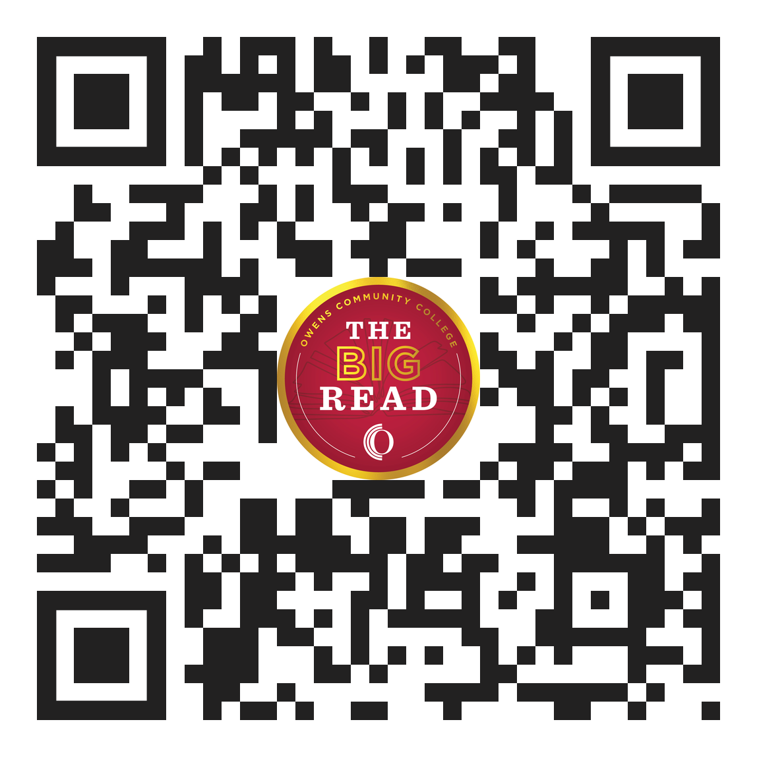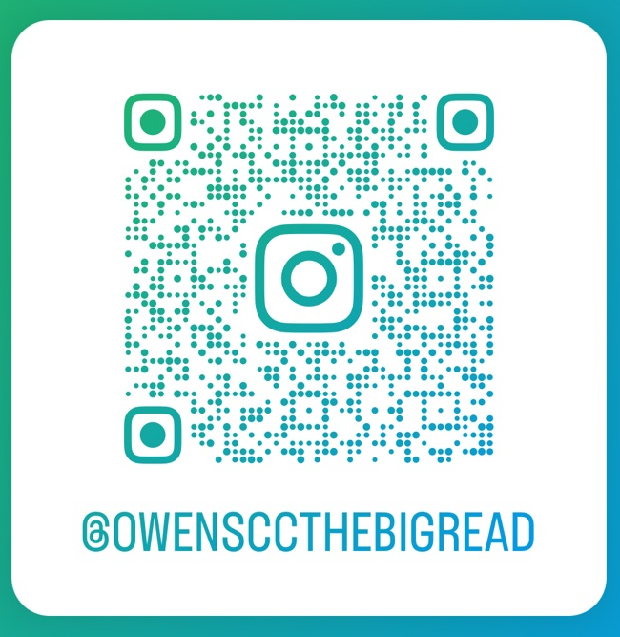

Goal: The goal of Owens Community College’s BIG Read is to bring awareness of different perspectives through books and accompanying activities on campus and in our surrounding communities.

2024-25 Themes: Deaf culture, history of Deaf culture and struggle for rights, Deaf community, American Sign Language and other communication of deaf or hard of hearing individuals, challenges deaf and hard of hearing individuals face in a world built on being able to hear, the privilege of hearing, and ableism.

Where and when can I get the book? We will have copies in a few weeks and will email you when they arrive. We will be selling bookmarks w/ a free book on September 5 for your students; details are below.
2024-2025 BIG Read Tentative Programming

SUMMER 2024 SEMESTER EVENTS

Book Club—CH 117*
June 25—12 p.m.
Join us as we dive into the 2024-5 BIG Read Book.
*If on the Findlay-area Campus, reach out to Paul Weaver in the library to get linked to the Toledo-area Campus.

Book Club—CH 117*
July 24—12 p.m.
Join us as we dive into the 2024-5 BIG Read Book.
*If on the Findlay-area Campus, reach out to Paul Weaver in the library to get linked to the Toledo-area Campus.

BIG Read Faculty Workshop—CH 117*
August 14—12-2 p.m.
Join us as we explore how to use the 2024-5 book and themes in your classroom and offices.

FALL 2024 SEMESTER EVENTS

Confronting Biases——CH 100
August 29—11 a.m.-12 p.m.
Unconscious biases that revolve around race, gender, sexual orientation, religion, socioeconomic status, etc. are in the background of our minds; we are often unaware of how they influence our decisions and thinking. Join Dr. Kristen Price, Professor of Psychology, and Kim Musser-Quist, Professor of ASL, as we discuss overcoming these biases during this dynamic presentation.

Bookmark Sale
September 5
Come and get your very own bookmark with a free copy of TBA.

Fall Kick Off & Book Club—CH 117*
September 18—12 p.m.
Join us as we kick off the BIG Read for the fall semester with free books and other BIG Read Promotional Goodies, take a dive into the 2024-5 BIG Read Book, and learn some basic ASL.
*If on the Findlay-area Campus, reach out to Paul Weaver in the library to get linked to the Toledo-area Campus.

Documentary Film Showing—CH 100 & Livestream (Discussion Only): TBA.
October 3—12 a.m.
Join us as we watch and discuss this documentary with themes revolving around Deaf culture; live discussion with TBA.

Human Library—HH 123
October 17—10 a.m.-12 p.m.
Humans as books? Yes! Join us as we “check out” human books to better understand someone who has experienced prejudice or has been stigmatized and ultimately, “unjudge.”

Book Club—CH 117*
November 7—12 p.m.
Join us as we dive into the 2024-2025 Book.
*If on the Findlay-area Campus, reach out to Paul Weaver in the library to get linked to the Toledo-area Campus.

“Let’s Talk BIG w/ Jane & Jen”
Thursdays, all semester long | 7 a.m. | 10 a.m. | 7 p.m., | 10 p.m. | Owens Community College Radio or the OCCR YouTube Channel.

SPRING 2025 SEMESTER EVENTS

Bookmark Sale
Book Club
Feature Film Showing
Deaf Performer(s)
“The Faces Of” Art Exhibit
“The Faces Of” Art Exhibit Reception
Author Visit

What is your BIG adventure?

Use the adventure that best fits with your course.

BIG Course includes activities such as DB, class discussions, case studies, etc. that
explore the book themes and encourage students to read the book and
participate in events.

BIG+ Course includes activities such as DB, class discussions, case studies, etc. that
explore passages of the book and themes and encourage students to
read the book and participate in events.

Total BIG Course includes activities such as DB, class discussions, case studies,
essays, etc. that explore the book and book themes, require students to read
the book, and integrate events into the course.

Reading Circles

Possible Reading Circle Books
*Synopses excerpted from Amazon and Goodreads.

All the books below are available by checking them out with Christine in the Founders Hall Front Office.

The Deaf Heart by Willy Conley—Told through a series of quirky, irreverent short stories and letters home during the early 1980s, The Deaf Heart chronicles a year in the life of Dempsey “Max” McCall, a Deaf biomedical photography resident at a teaching hospital on the island of Galveston, Texas. For more, see goodreads.com.

The Unheard: A Memoir of Deafness and Africa by Josh Swiller—Deaf since a young age, Swiller spent his formative years in frustrated limbo on the sidelines of the hearing world, encouraged by his family to use lipreading and the strident approximations of hearing aids to blend in. It didn't work. After college, he set out to find a place so far removed that his deafness would become irrelevant. For more, see amazon.com.

Resilient Silence: A Deaf Experience Suspense Novel by Peter M. Quint—Resilient Silence is the divergent path between two brothers living in futuristic America. Navigating extreme personal differences, they eventually converge to compete in the Bloomsday road race and learn the hidden strength of resilient silence that comes from being Deaf in a hearing world. For more, see goodreads.com.

EveryDay I Am Just Deaf: Life in a Hearing World with Deaf Queen Boss by Kellina Powell—In her first book, Everyday I am Just Deaf, Kellina exposes her inner thoughts and feelings to get readers thinking: what it’s like to be deaf in a hearing world, what barriers can be removed, and what contributions can be made to level the playing field. For more, see amazon.com.

Finding Zoe by Brandi Rarus—Brandi Rarus lost her hearing at age six. She met her husband Tim after seeing him at the Gallaudet Uprising, and they fell in love a year later, devoting their lives to each other, improving the lives and communication for the Deaf, and later, raising their three hearing sons. Against the backdrop of Deaf America, Finding Zoe is an uplifting story of hope, adoption, and everyday miracles. For more, see goodreads.com.

True Biz by Sara Novic—This revelatory novel plunges readers into the halls of a residential school for the deaf, where they'll meet Charlie, a rebellious transfer student who's never met another deaf person before. This is a story of sign language and lip-reading, disability and civil rights, isolation and injustice, first love and loss, and, above all, great persistence, daring, and joy. For more, see goodreads.com.

Dark Pines by Will Dean—An isolated Swedish town. A deaf reporter terrified of nature. A dense spruce forest overdue for harvest. A pair of eyeless hunters found murdered in the woods. It’s week one of the Swedish elk hunt and the sound of gunfire is everywhere. When Tuva Moodyson investigates the story that could make her career she stumbles on a web of secrets that knit Gavrik town together. Are the latest murders connected to the Medusa killings twenty years ago? Is someone following her? Why take the eyes? Tuva must face her demons and venture deep into the woods to stop the killer and write the story. And then get the hell out of Gavrik.

Reading Circles+
Really a Multi-media Circle…

Possible Reading Circle+

Podcasts
The Listening Brain
Seen and Not Heard
The Hear Me Out! Podcast
The Other Side of Deaf
Our Deaf Ways
What The Deaf?!
ASL Word of the Day
All About Audiology – Hearing Resources to Empower YOU
Cross Cultural Expressions Podcast’s
Let’s Talk BIG w/ Jane & Jen
Documentaries*
Deaf Out Loud
Mother, Father, Deaf
Yucatec Maya Deaf Sign
In the Land of the Deaf
Land if Silence and Darkness
The Listening Project: Young Adults Living with Hearing Loss
You Can’t Ask That, episode # 2
Following the Ninth: In the Footsteps of Beethoven’s Final Symphony

Feature Films*
Creed 3
Godzilla vs Kong
The Sound of Metal
The Belier Family
A Quiet Place
Wonderstruck
Dear Frankie
The Heart is A Lonely Hunter
Miracle Worker
Sweet Nothing in My Ear
Only I Can Hear
Becoming Helen Keller
Louis van Beethoven
Voice of the Voiceless
Avenged
Marie’s Story

*All can be made available through either Kanopy or Swank Databases at the OCC Library.

Helpful Sites and Information:

OCALI Glossary of Terms: https://deafandblindoutreach.org/dhh-guidelines-for-the-assessment-glossary
Deaf Culture Tip Sheet: https://www.sscc.edu/services/assets/guide-71-PEPNet-tipsheet-deaf-culture.pdf
Correct Terms Referring to Deaf People by Jenleora: https://soundforlight.com/correct-terms-referring-to-deaf/
Deaf culture: what is it, history, aspects, examples and facts by Ana Sofia Gala: https://www.handtalk.me/en/blog/deaf-culture/
National Deaf Center: https://nationaldeafcenter.org/
Deaf Culture Center: https://deafculturecentre.ca/
Exploring the Rich Heritage of Deaf People from CSD: https://csd.org/stories/rich-heritage-of-deaf-people/
Laurent Clerc National Deaf Education Center: https://web.archive.org/web/20181107033343/http://www3.gallaudet.edu/clerc-center.html
Understanding Deaf Culture from Mass.gov: https://www.mass.gov/info-details/understanding-deaf-culture

Thank you for joining us!

Please let us know how we did and what questions you still have by filling out the survey after clicking on this QR code.

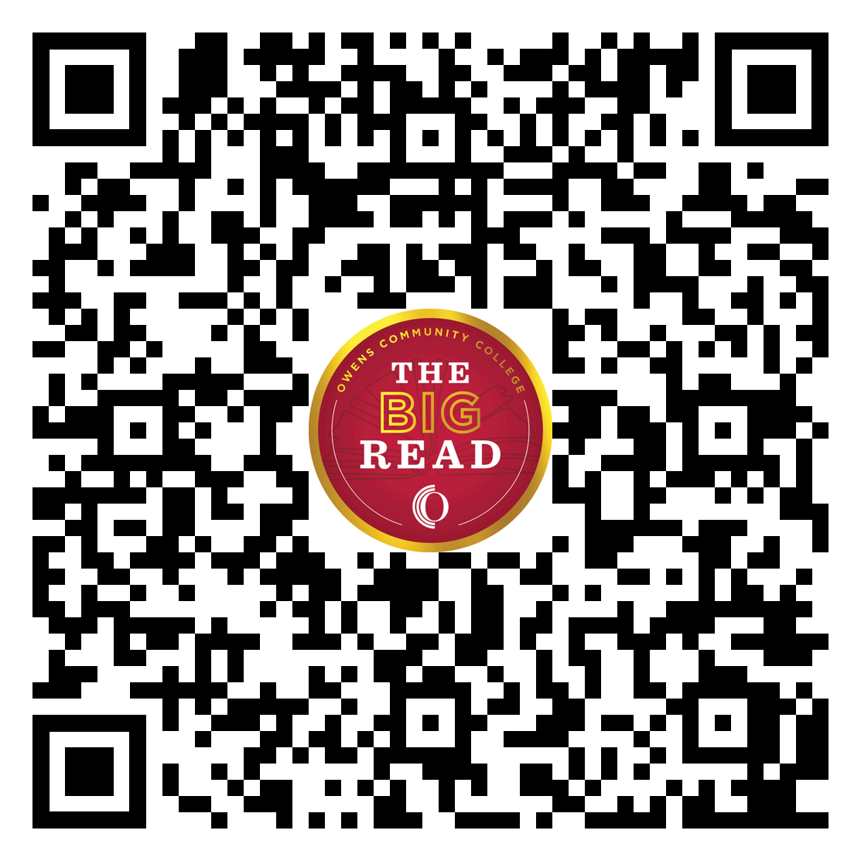

To find this information and more online, use this QR code.

